The Los Angeles County Asian American Employees Association

cordially invites you to participate in our

“Scholarship Fundraiser” Turnaround to


Spend a fun-filled day of…

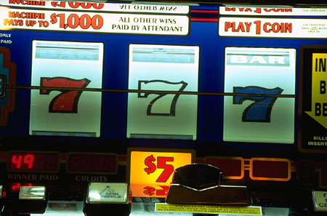
Playing your favorite slots, eating,
shopping or bowling.

When: Saturday, July 14, 2012

Cost: $25 (per person)

Departing Time: 8:15 AM - 329 N. Vendome St., LA, 90026
9:00 AM – Ontario Mills JcPenney’s - 1 Mills Circle, Ontario, CA 91764


Expected Return Time: 7:00 PM

Price includes: Roundtrip to/from casino,
snacks, drinks & a $5 food voucher.


Send Reservations To:
Karen Tu
lacaaea.mail@gmail.com
P.O. Box 86334
Los Angeles, CA 90086-0334
Attention: Viejas Committee
Registration Deadline:
Friday, July 6, 2012
NO REFUNDS!!!
FIND YOUR OWN REPLACEMENTS.

________________________________________________________

Los Angeles County Asian American Employees Association
Scholarship Fundraiser Turnaround – Saturday, July 14, 2012

– NO REFUNDS!!! FIND YOUR REPLACEMENTS!!! –

Enclosed is my payment for: ____ reservation(s) @ $25.00 each. Total Amount Enclosed: $ _____

Members paying by check, make payable to: “LACAAEA.” Please write your California Driver License #
and Employee # on your check. There will be a $20.00 service charge for all returned checks.
Non-members must pay by cash, money order, or cashier’s check.

Name: |  |  |  |  |  | Phone #: |  |  |  |  | Fax No.:
Department: |  |  |  |  |  | Email:
Address:
City: |  |  |  |  | State: |  | CA |  |  | Zip Code:

